Examine the following sentences
Tick the exclamation sentences.

- What a lovely dress you have!
- Don’t wear that dirty dress.

- How tired the child looks!
- Take some rest please.

- What an exceptional girl she is!
- Don’t be a naughty girl.

- Wow! It is a brilliant idea!
- Keep your mouth shut.

- What a pleasant day!
- It’s overcast outside.

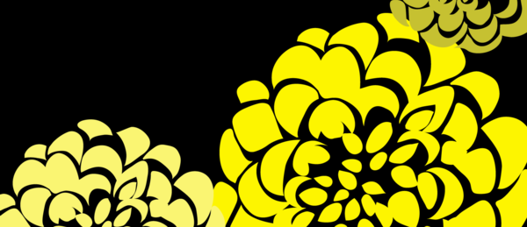
- How wicked the wolf was!
- The wolf is so wicked.

- How tall and fierce the giant looks!
- The giant is so friendly.

