Rapid fire Perimeter

- What would the perimeter of a square be if it had a side length of 7cm
  - 21cm b. 54cm c. 28cm d. 35cm

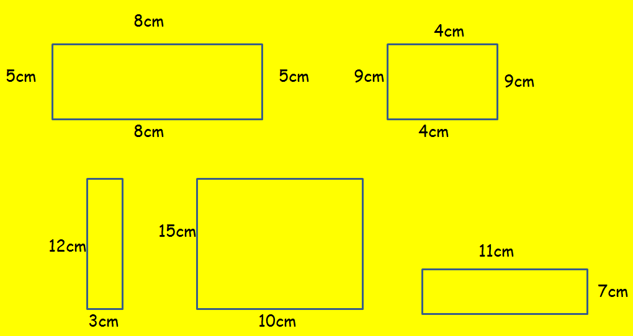
- Find perimeter of these rectangles

- How many different rectangles can you draw which have a perimeter of 24cm?

- How many triangles can you draw with a perimeter 16cm?

- Put these items in order with the largest perimeter first, estimate and do not measure them.

Door, Desk, worksheet, classroom.

_____________,_____________,________________,_______________

- How many:
cm in a metre

mm in a cm

mm in a metre

- Perimeter is normally measured in
  - m b. cm c. mm d. feet

- Find the perimeter of a square with one side equalling 7
  - 14 b. 35 c. 28 d. 22

- What is useful to work out the area of a small 2D shape?

  - Measuring jug b. ruler c. tracing paper d. meter stick

- A square has a perimeter of 32cm. How long are the sides?

  - 4cm b.8cm c. 10cm d. 5cm

